**🚗 E-VEHICLE DATA ANALYSIS USING SQL**

**🔹 STEP 1: CREATE A TABLE IN MYSQL**

1. create schema EvechileDB;

USE EVECHILEDB

1. create table evechiles(

VIN VARCHAR(20) PRIMARY KEY,

COUNTRY VARCHAR(100),

CITY VARCHAR(100),

STATE VARCHAR(10),

POSTAL_CODE INT,

MODEL_YEAR INT,

MAKE VARCHAR(50),

MODEL VARCHAR(100),

ELECTRIC_VECHILE_TYPE VARCHAR(50),

CLEAN_ALTERNATIVE_FUEL VARCHAR(50),

ELECTRIC_RANGE INT,

BASE_MSRP DECIMAL(10,2),

Legislative INT,

DOL_VECHILE DECIMAL(10,2),

VECHILE_LOCATION VARCHAR(255),

ELECTRIC_UTILITY VARCHAR(255),

CENSUS_TRACT DECIMAL(15,2)

);

1. SELECT * FROM EVECHILES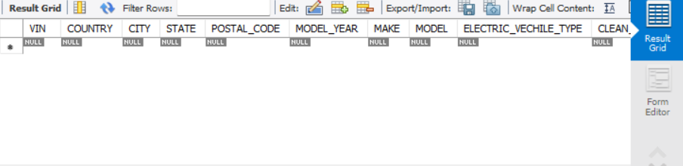

**🔹 STEP 2: IMPORT DATA FROM CSV**

1. LOAD DATA LOCAL INFILE "C:\Users\Vinusha\Desktop\vincent\E-vechicle data.csv"

INTO TABLE EVECHILES

FIELDS TERMINATED BY ','

ENCLOSED BY '"'

LINES TERMINATED BY '\n'

IGNORE 1 ROWS;

1. select * from evechiles;

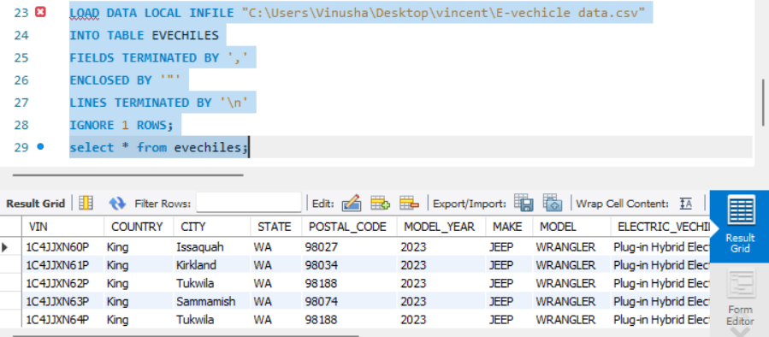

**🔹 STEP 3: VERIFY THE DATA**

1. Check if the data is imported correctly:

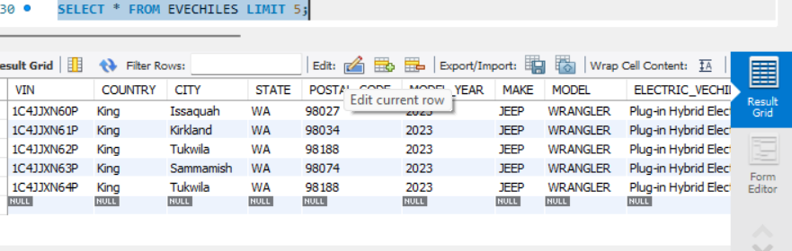

1. Check column structure: 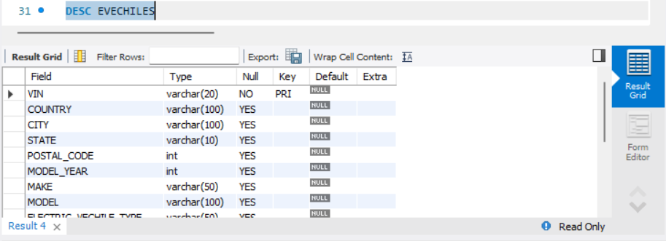

**STEP 4: DATA CLEANING & PREPARATION**

**🔹 Check for missing values:**

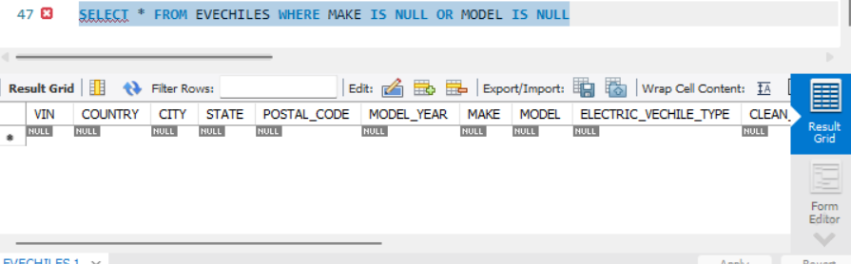

**🔹 STEP 4: PERFORM SQL ANALYSIS**

1. **Total Number of EVs in the Dataset**

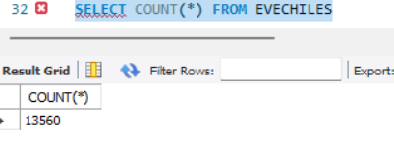

1. **Top 5 Most Common EV Models**

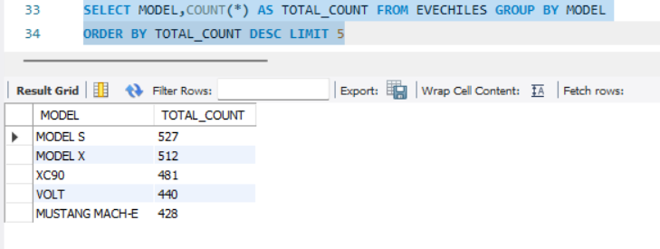

1. **Count vehicles by manufacturer:**

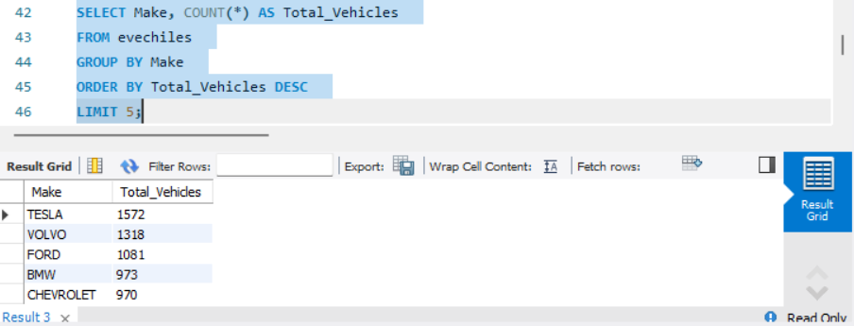

1. **Average Electric Range by Brand**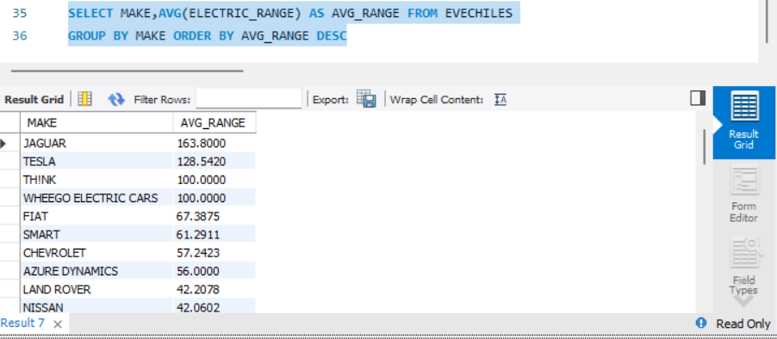
2. **Find the top cities with the most electric vehicles:**

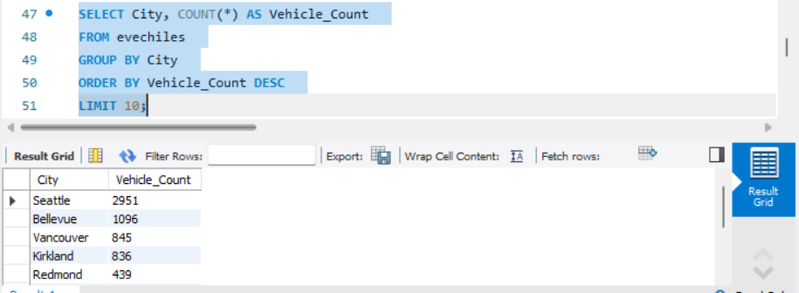

1. **Most Common EV Brands in a Specific County (e.g., King County)**

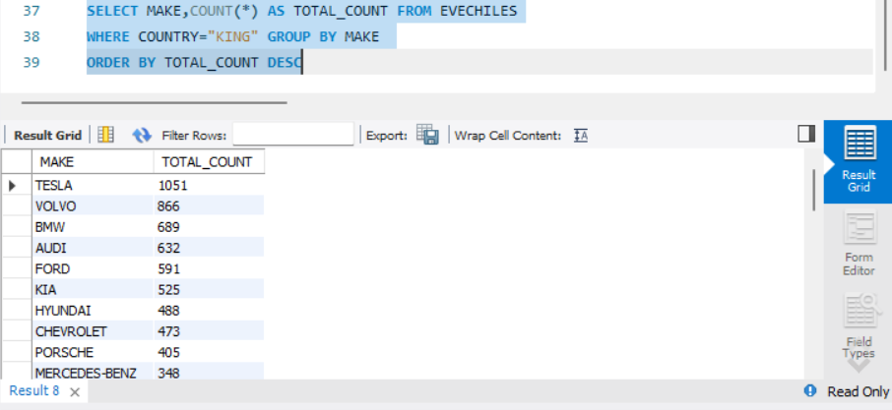

1. **Optimize query execution with EXPLAIN:**

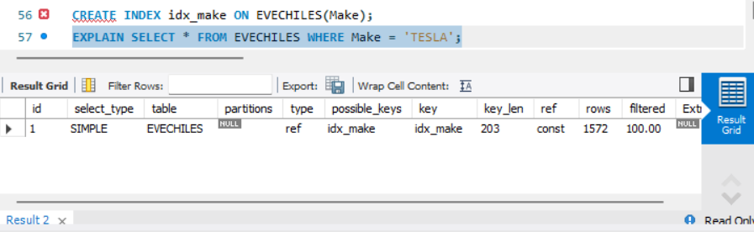

1. **EV Models with the Highest Electric Range**

